1. Create an AWS folder and clone the ADK from the cloud.

Git clone: <https://github.com/aws-samples/amazon-kinesis-video-streams-media-interface.git>

Figure 30: Clone ADK from the cloud

1. Run the following command for MIPS GCC5.40

|  |
| --- |
| export PATH/home/xxxx/ingenic/tools/mips-gcc540-glibc222-64bit-r3.3.0/bin/:$PATH  export CC=mips-linux-gnu-gcc  export CXX=mips-linux-gnu-g++ |

**Note**: These exports can be added in the environment variables. Ensure to add the path for cross-compiler binaries.

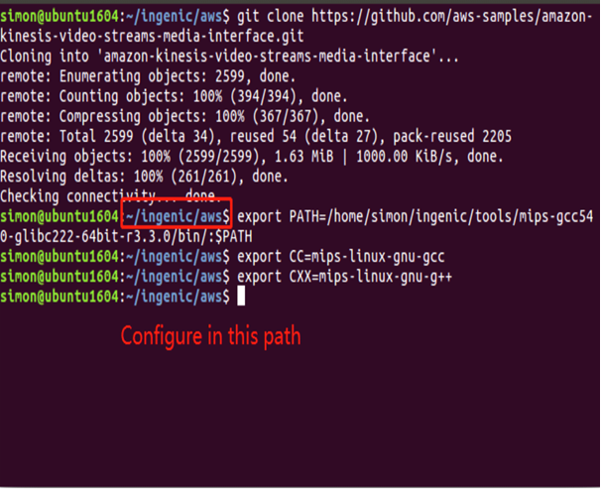

Figure 31: Export - MIPS GCC5.40

1. Copy dependent files from Ingenic SDK to Amazon ADK

|  |
| --- |
| cp -rf /home/xxx/INP3201_AWS_DEMO/T31_SNIPE_XXXXXXXX/FREERTOS_SDK_XXXXXXXX/ISVP-T31-1.1.5-XXXXXXXX/software/sdk/Ingenic-SDK-T31-1.1.5-XXXXXXXX/freertos_sdk/5.4.0/* /home/xxxx/INPIOT_GIT/AWS_KINESIS/amazon-kinesis-video-streams-media-interface/3rdparty/T31/ |

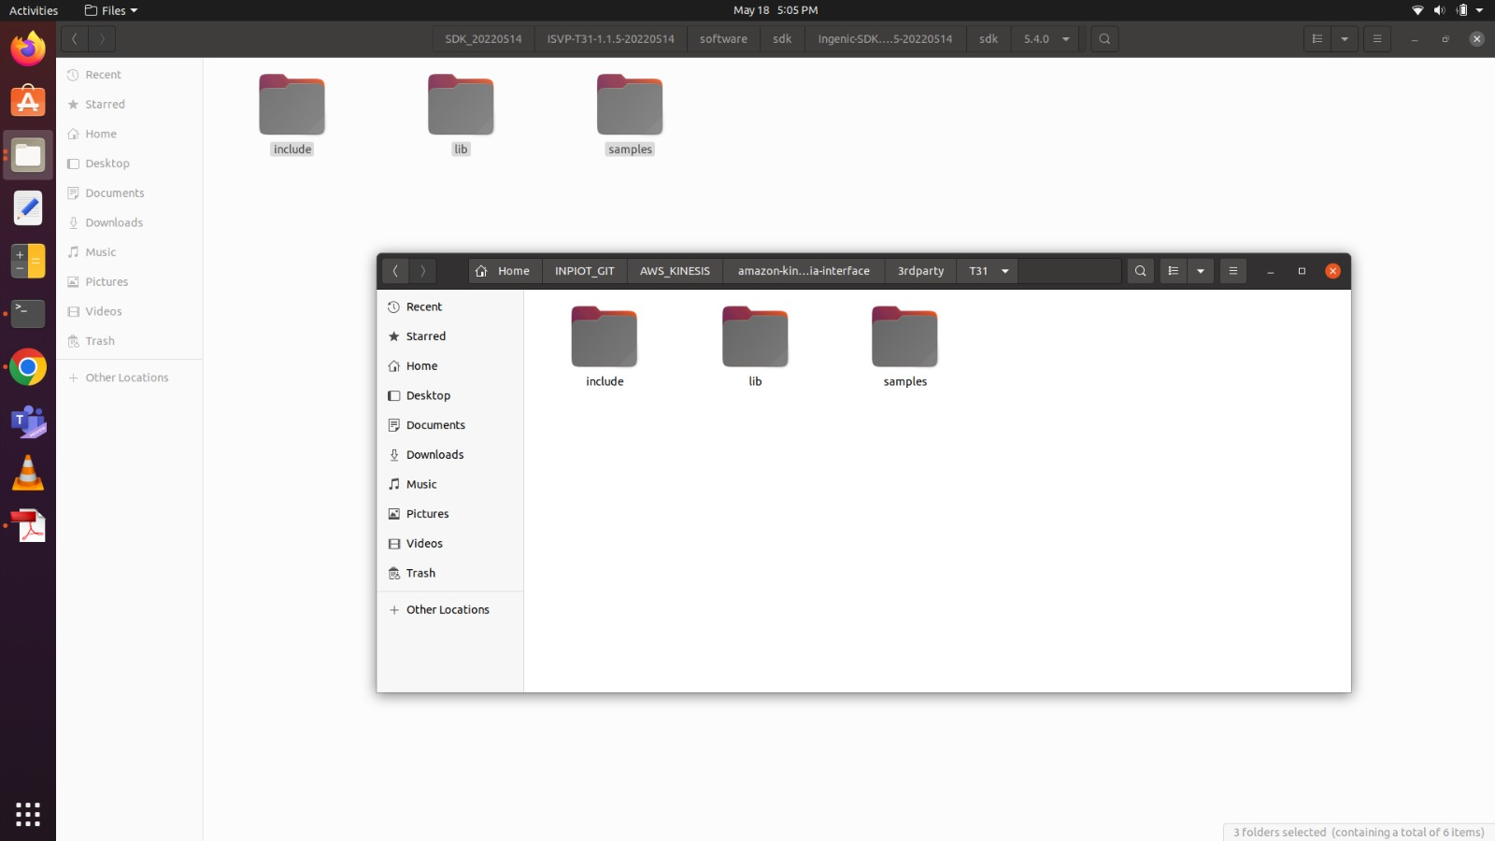

Figure 32: Copy dependent files

1. Enter path: amazon-kinesis-video-streams-media-interface. Create a folder ‘build’ and enter the folder.

|  |
| --- |
| cd amazon-kinesis-video-streams-media-interface  mkdir build; cd build; |

Figure 33: Create build folder

1. Check the cmake version installed. Run cmake to generate - makefile.

|  |
| --- |
| /home/xxxx/ingenic/tools/cmake-3.13.3/build/bin/cmake –version  /home/xxxx/ingenic/tools/cmake-3.13.3/build/bin/cmake .. -DBUILD_WEBRTC_SAMPLES=ON -DBUILD_KVS_SAMPLES=ON -DBOARD=T31 |

**Note**: After configuring the environment, install cmake 3.13.3 to user path and not the system path.

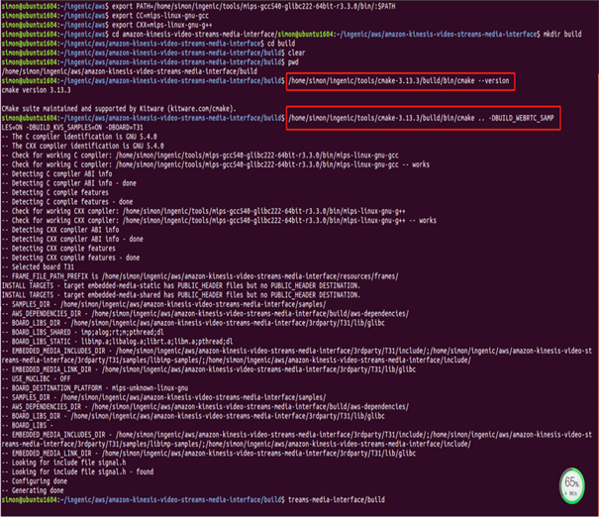

Figure 34: Generate makefile

1. Execute make to generate the executed file.

|  |
| --- |
| make -j4 |

Figure 35: Execute make

1. Copy kvswebrtcmaster-static to the T31z filesystem, insmod the necessary drivers in T31z and execute: kvswebrtcmaster-static to stream the video to AWS cloud.